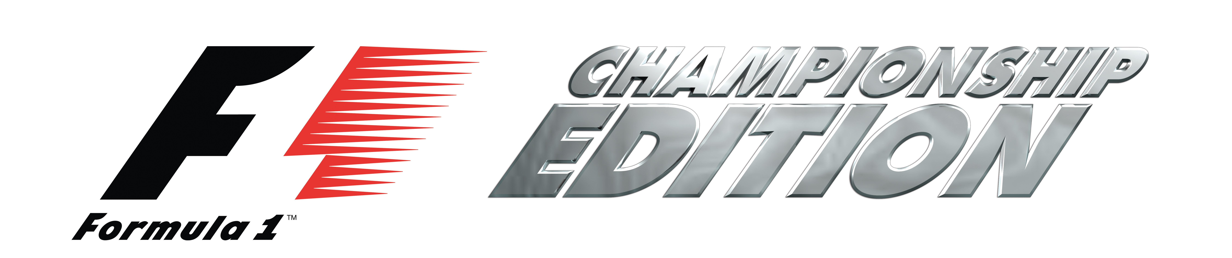

FORMULA ONE™ has evolved…
Welcome to the next level in racing

Key Features:

- The 2006 season: Featuring all the official cars, circuits, drivers and teams of the 2006 FIA FORMULA ONE WORLD CHAMPIONSHIP™, including newcomers SCUDERIA TORO ROSSO, SUPER AGURI F1 TEAM and MIDLAND F1 RACING.

- Next-Gen experience: High definition visuals, full surround sound audio, extensive circuit and car details, plus authentic vehicle damage guarantees the most realistic racing experience ever. This is as close as you can get to the real thing.

- True realism: Feel pure GRAND PRIX pressure with formation laps, interactive pit stops, official race rules, unexpected collisions and race incidents. Experience what makes FORMULA ONE the most exhilarating motor sport on the planet.

- Pickup and play: Easy access for drivers of all abilities with driving aids, spin recovery and automatic braking assistance.

- Exclusive to PLAYSTATION®3: The only official game of the 2006 FIA FORMULA ONE WORLD CHAMPIONSHIP™ available on next-gen consoles.

Game © 2006 Sony Computer Entertainment Europe. Published by Sony Computer Entertainment Europe. Developed by SCEE Studio Liverpool. An official product of the FIA FORMULA ONE WORLD CHAMPIONSHIP.

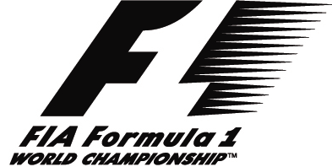FORMULA ONE, FORMULA 1, F1, FIA FORMULA ONE WORLD CHAMPIONSHIP, GRAND PRIX and translations thereof are trademarks of Formula One Licensing
,
,

BV, a Formula One Group Company. Licensed by Formula One Administration Limited, a Formula One Group Company. All rights reserved.

-Ends-

Notes to Editors

For more information please contact your local PR Manager.
About Sony Computer Entertainment Europe Ltd.
Sony Computer Entertainment Europe (SCEE), based in London, is responsible for the distribution, marketing and sales of PlayStation®2 and PSP™ (PlayStation®Portable) software and hardware in 104 territories across Europe, the Middle East, Africa and Oceania. SCEE also develops, publishes, markets and distributes entertainment software for these formats, and manages the third party licensing programs for the platforms in these territories. Between its European debut on 24th November 2000 and the end of March 2006, over 38 million PlayStation®2 consoles have been shipped across the SCEE territories, over 103 million worldwide, making it one of the most successful consumer electronic products in history. Between its European debut on 1st September 2005 and the end of March 2006, over 5 million PSP systems have been shipped across the SCEE territories, with over 17 million shipped worldwide since its Japanese launch in December 2004.
More information about PlayStation products can be found at www.playstation.com and www.yourpsp.com or visit the Virtual Press Office at www.scee.presscentre.com
PlayStation and the PlayStation logo are registered trademarks of Sony Computer Entertainment Inc. PSP and UMD (Universal Media Disc) are trademarks of Sony Computer Entertainment Inc. All other trademarks are property of their respective owners.

